Adriana Nicolau and Teresa Iribarren

The Staging of Ciudad Juárez’s Feminicides: Àlex Rigola and Angélica Liddell Speak for the Victims

Tackling violence against women in the theatre is often a controversial matter. To identify the ethical risks that victim representation may entail, we conduct a comparative analysis of two works about Ciudad Juárez’s feminicides staged in Barcelona: 2666 (2007), an adaptation of Roberto Bolaño’s novel directed by Àlex Rigola, and House of Strength (2011) by Angélica Liddell. This article argues that while Rigola reduces victims to mere sexual objects with no narrative of their own, Liddell places the voice and resilience of Mexicans in the foreground and represents their bodies respectfully. Adriana Nicolau is completing her doctoral studies on ‘Feminisms in contemporary Catalan theatre’ at Universitat Oberta de Catalunya (UOC) in Barcelona. Her publications include articles for Feminismo/s. Teresa Iribarren is an assistant professor at UOC, where she is the Director of the Catalan Literature, Publishing, and Society research group. Her current research focuses on narratives of violence and the promotion of human rights in literature.

Key terms: theatre, violence against women, victim representation, Roberto Bolaño, body, feminism, gender, memory.

THE ARTISTIC representation of human rights violations and their victims has often aroused controversy. Fields such as memory studies, moral philosophy, trauma studies, and the study of the narratives of violence have addressed the complex imbrication of ethics in aesthetics, and the representation and exploitation of the suffering of others. Recovering traumatic experiences and bring-ing victims’ narratives into the spotlight can contribute to making conflicts and their causes public and to promoting victim recognition. However, this mediation task is not exempt from ethical risks: its intervention can re-traumatize the victims and make them feel that their suffering has been illegitimately usurped.

Motivated by different aims, creators from multiple disciplines have felt legiti-mated to act as representatives of the victims of human rights violations, ‘bearing witness to politics through art’.1 Such has been the case of the Ciudad Juárez feminicides, a par-adigm of the global rise of violence against women that has become a recurring artistic and literary topic.2 Filmmakers, visual

artists, performers, playwrights, and writers have recreated the conflict across different genres, taking on the risk involved in inter-preting the complex reality of Ciudad Juárez, sometimes from distant locations. The work that has most widely contributed to the inter-national dissemination of the Ciudad Juár-ez’s feminicides is most likely Roberto Bolaño’s well-known 2666 (2004), an arche-type of the global novel,3 which has been adapted for the stage on three occasions.4

In the debate on feminicides, critical voices have denounced some creators’ inability to ‘elucidate pain, this intimate aspect of vio-lence’, as well as their opportunistic use of ‘horror to move’.5 In other words, they por-tray violence and their victims in a sensation-alist way to attract wider audiences. The representation of feminicide involves particu-lar ethical dilemmas that are highly condi-tioned by the victim’s gender. Indeed, their representation risks reproducing and thus solidifying certain patriarchal stereotypes that reduce women to passive victims, particularly when represented as rapeable6 and killable bodies.7 The problem worsens when these

**Downloaded from** [**https://www.cambridge.org/core**](https://www.cambridge.org/core)**. UNSW Library, on 14 Sep 2020 at 03:17:09, subject to the Cambridge Core terms of use, available at**

[ntq 36:2 (may 2020)](https://www.cambridge.org/core/terms) © [cambridge university press doi:10.1017/S0266464X2000024X](https://doi.org/10.1017/S0266464X2000024X) 131 [**https://www.cambridge.org/core/terms**](https://www.cambridge.org/core/terms)**.** [**https://doi.org/10.1017/S0266464X2000024X**](https://doi.org/10.1017/S0266464X2000024X)

narratives become hegemonic, gaining global audiences and hindering the emergence of alternative accounts that make victims’ agency, activist protests, and processes of care, healing, and emancipation visible.

As Judith Butler explains when speaking of war images from Afghanistan in American newspapers, certain representations

do not show violence, but there is a violence in the frame in what is shown. That latter violence is the mechanism through which certain lives and deaths either remain unrepresentable or become repre-sented in ways that effects their capture (once again) by the war effort.8

In this sense, if representation of victims subjects them to the dehumanization that pre-cedes all violent acts against other human beings, it will be reproducing the very condi-tions of violence. Butler admits that knowledge of violent acts implies their representation, but she demands a necessary contextualization to avoid a ‘derealization of loss’ that can cause an ‘insensitivity to human suffering and death’ in the audience.9 According to Butler, ‘[t]his dere-alization takes place neither inside nor outside the image, but through the very framing by which the image is contained’.10 When it comes to violence against women and feminicide, this framing particularly concerns the representa-tion of women and their bodies.

This article maintains that Butler’s develop-ments on American media can be translated into the analysis of engaged representations of Ciudad Juárez’s feminicides, which would need to build a framing that provides the audi-ence with a critical depiction of Ciudad Juárez’s socio-political and economic situation and that avoids re-inscribing women in the narratives that victimize them. Following this premise, this article analyzes two Spanish plays that have toured around Europe and that the authors have seen at the Teatre Lliure in Barce-lona. These are: 2666 (2007), an adaptation of Roberto Bolaño’s posthumous novel by Pablo Ley and Àlex Rigola, who directs the piece as well;11 and La casa de la fuerza (House of Strength; 2009) by Angélica Liddell.12

Both pieces enjoyed great public success and received critical acclaim in Barcelona, as well as several prizes. In Catalonia 2666

received the Critics Prize 2008, the Qwerty Prize 2008, and the Max Prize 2009. Mean-while, House of Strength propelled Liddell to European heights when it was premiered at the prestigious Avignon Festival in France, also earning her the National Prize for Dramatic Literature in Spain (2012), making Liddell the second woman to receive it. Both are lengthy plays (around five hours each) and present Ciudad Juárez’s feminicides within a broader reflection. In 2666, the fem-inicides are depicted as the materialization of evil in parallel to other historical phenom-ena, including the Second World War and the atrocities of the Holocaust. In House of Strength, on the other hand, they are echoed by bloody attacks on Gaza but appear, above all, as the extreme form of a continuum of sexist violence.

The novelty of our reading lies in three fundamental contributions: the comparison of the two plays; the focus on their particular ways of speaking for the victims; and the identification of the ethical, and gendered risks that this task involves. While both plays convey a narrative of denunciation, victim recognition, and mourning, the contextualiza-tion of the feminicides and the representation of the victims are diametrically opposed. Our argument begins with a brief introduction to Ciudad Juárez’s feminicides, pointing out the key aspects of the conflict in order to analyze their artistic representation.

The close reading will follow the chrono-logical order of the staging of both plays. In the 2666 section, we analyze the play and its adaptation from Bolaño’s novel; in the House of Strength section, the preceding analysis of Rigola’s piece develops our comparative analysis. Through this comparison it is shown that Rigola and Ley’s adaptation schematizes the complex reality of the Mexican border that Bolaño’s novel portrays, reduces victims to sexual objects with no narrative of their own, perpetuates the stereotype of women without a voice, and blurs the lines of their class and racial identities.13 Conversely, we demon-strate that Liddell’s work places Mexican women’s voices at centre-stage. House of Strength not only confronts European specta-tors with Mexican women’s trauma through

**Downloaded from** [**https://www.cambridge.org/core**](https://www.cambridge.org/core)**. UNSW Library, on 14 Sep 2020 at 03:17:09, subject to the Cambridge Core terms of use, available at**

[132](https://www.cambridge.org/core/terms)

[**https://www.cambridge.org/core/terms**](https://www.cambridge.org/core/terms)**.** [**https://doi.org/10.1017/S0266464X2000024X**](https://doi.org/10.1017/S0266464X2000024X)

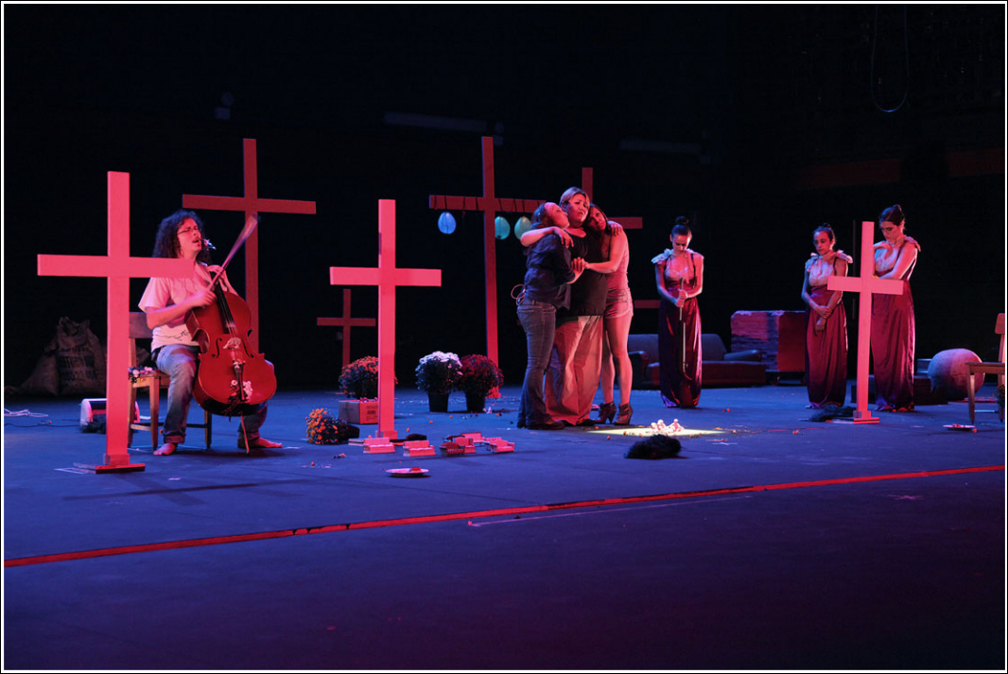

La casa de la fuerza. Photo: courtesy of Julio Calvo.

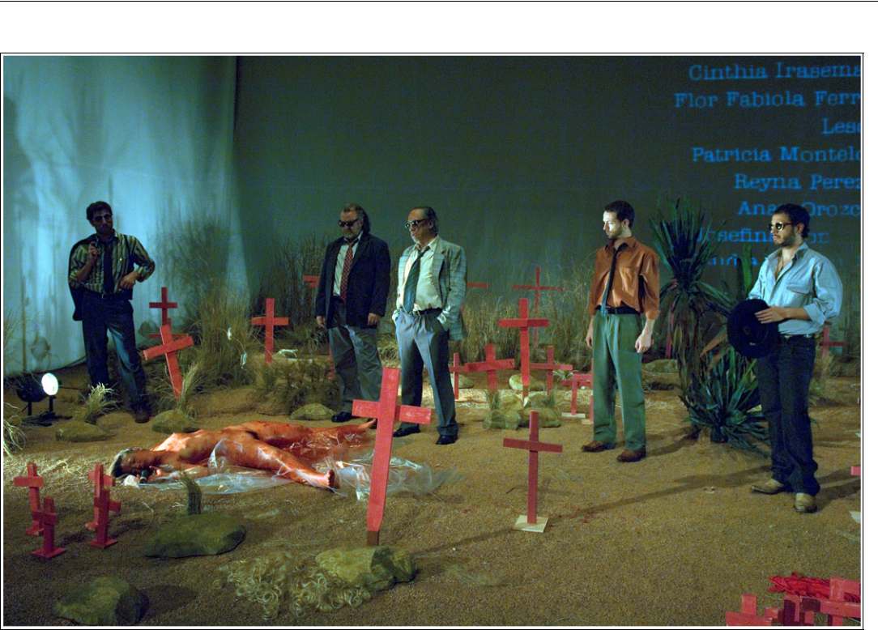

2666. Photo: courtesy of Teatre Lliure.

|  |  |  |
| --- | --- | --- |
| **Downloaded from** [**https://www.cambridge.org/core**](https://www.cambridge.org/core)**. UNSW Library, on 14 Sep 2020 at 03:17:09, subject to the Cambridge Core terms of use, available at** | |  |
| [**https://www.cambridge.org/core/terms**](https://www.cambridge.org/core/terms)**.** [**https://doi.org/10.1017/S0266464X2000024X**](https://doi.org/10.1017/S0266464X2000024X) | 133 |  |
|  |  |

the testimony of three Chihuahuan actresses, but also enacts a recovery and healing ritual rendered possible by female solidarity in a poetic proposal of connection between women of the global South and women of the global North, embodied in the play by Mexican and Spanish actresses.

The Ciudad Juárez Feminicides

Ciudad Juárez is an industrial town located on Mexico’s northern border and the largest in the state of Chihuahua. A key node in the drug-trafficking route from Colombia to the USA, it harbours a powerful drug cartel, which has the connivance of a local oligar-chy composed of political, judicial, and police authorities. This particular situation has led to levels of violence among the high-est in Mexico, a country with overwhelming crime rates. One of the consequences of this climate of extreme violence is the high fem-inicide rate, which has remained stable since 1993. From 1993 to 2017, more than 1,700 murdered women were found in the barren land that surrounds the city, most of whom had previously been raped and tor-tured.

Due to NAFTA, the free trade agreement signed by Mexico, the USA, and Canada in 1994, the adoption of neoliberal policies in the border area caused the uncontrolled growth of the maquiladoras industry.14 Preferential recruitment of women led them to access pub-lic space, which brought about the disruption of the traditional gender division of labour, a reality that came into conflict with the patri-archal structure of Mexican society. This transformation of the workplace, which allowed women to break free from their con-finement in the domestic space, not only did not end their subordination, but it also turned them into the victims of the systemic and anonymous violence of capitalism.15 These women work under conditions of exploita-tion; they are poor, vulnerable, often immi-grants from other parts of Mexico, and mostly indigenous. They are also very young, which is why some academics use the word ‘juvenicidio’.16 These women are the most

common victims of feminicide. Consequently, López-Lozano maintains that it is in the maqui-ladoras where the process of the dehumaniza-tion of women that culminates in feminicide begins.17

The crimes are a problem ‘that is both pub-lic and private, implicating both the state (directly or indirectly) and individual perpe-trators (private or state actors); it thus encom-passes systematic, widespread, and everyday interpersonal violence’.18 The huge power of the local oligarchy has shielded the negligence and abuse by the police and judicial bodies. Hence, almost all of the crimes have gone unpunished. Also, groups of victims’ mothers and other very politically active people tied to their cause have been the subject of repeated threats, coercion, and murder. As a result of these crimes, Ciudad Juárez ‘has become a symbol for all of that is wrong with globaliza-tion, transnational exploitation and the Latin American form of masculine domination known as machismo’.19

Academic criticism, often very activist, has analyzed the phenomenon from multiple points of view. Ciudad Juárez’s case is gener-ally understood as a ‘systematic sexual fem-inicide’ in contrast to feminicide by partners, ex-partners, and other relatives, the most com-mon form in the first world.20 Authors such as Fregoso and Bejarano have advocated for the use of the term ‘feminicide’ to refer to this type of murder:

The scale and range of the violence in general and the specific brutality and severity of rape, sexual torture, and mutilation suggest high levels of misogyny and dehumanization of women. Treat-ing feminicide as the gendered form of homicide is thus misleading . . . In other words, unlike most cases of women’s murders, men are not killed because they are men or as a result of their vulner-ability as members of a subordinate gender; nor are men subjected to gender-specific forms of degrada-tion and violation, such as rape and sexual torture, prior to their murder.21

Alice Driver has reported that artistic produc-tions on feminicides have often perpetuated sexist stereotypes that dehumanize the victims. The majority of local media do the same. They exhibit corpses in an obscene way, they

**Downloaded from** [**https://www.cambridge.org/core**](https://www.cambridge.org/core)**. UNSW Library, on 14 Sep 2020 at 03:17:09, subject to the Cambridge Core terms of use, available at**

[134](https://www.cambridge.org/core/terms)

[**https://www.cambridge.org/core/terms**](https://www.cambridge.org/core/terms)**.** [**https://doi.org/10.1017/S0266464X2000024X**](https://doi.org/10.1017/S0266464X2000024X)

question the sexual life of the victims, which is not usually the case when the victims are men, and cast doubts on their morality when making observations about their way of dressing or occupying public space. In doing so, they fol-low a tradition ‘that reduce[s] women to sexu-alized bodies’.22 They omit the rest of their personal attributes and fetishize their bodies, rendering them available for the male gaze even after their death.

On the contrary, according to Driver, the works and the discourses that avoid this re-victimization put ‘the focus on the humanity of the Other’.23 The ethical decision to human-ize the victims – the murdered, their mothers, and other relatives – is usually materialized in the representation of their subjectivity and life experiences, such as in the documentary Seño-rita extraviada (Missing Young Woman, 2001) by Lourdes Portillo. Driver maintains that this kind of work often offers a solid contextualiza-tion, as is the case with the documentary Per-forming the Border (1999) by Ursula Biemann, or with the journalistic book Huesos en el desierto (Bones in the Desert, 2002) by Sergio González Rodríguez, which was a source for Roberto Bolaño’s 2666.24

2666

Àlex Rigola and Pablo Ley’s 2666, a theatrical synthesis of the monumental posthumous novel of the same name by Bolaño,25 pre-miered in its Spanish-language version at the Grec Festival in Barcelona in June 2007. Span-ish critics compared 2666 to the lengthy stag-ings of Krystian Lupa and Robert Lepage,26 and to David Lynch’s films.27 Theatre and aca-demic critics alike highlighted the enormous difficulty of adapting such a long and complex novel, and there was an almost unanimous consensus that the challenge of faithfully trans-lating the spirit of Bolaño’s work for the stage had been met, and with great success.

Bolaño’s 2666, published in Barcelona by the prestigious publishing house Anagrama, is an unfinished story of 1,124 pages, divided into five novels that present the vicissitudes of several characters throughout the twentieth and twenty-first centuries in Europe and the American continent. All the plots, which

address evil, the representation of horror, and literary myths, converge in Ciudad Juárez

– Santa Teresa in fiction. The different plots establish different degrees of relationship with the feminicides committed in the town, and the fourth part, The Part About the Crimes, focuses solely on this phenomenon. It pro-vides a long list of 119 raped, tortured, and murdered women’s bodies found in the city between 1993 and 1997. Several authors point out that the cold and detailed description of female bodies, which imitates a forensic style, seeks to reproduce physical violence through language in the way that women are reduced to ‘an inventory of dead bodies, whose holes are ducts, abject bodies abandoned to their luck in deserts, dumpsters’.28 Thus, the lan-guage of the novel ‘carries out an almost sec-ond violation on the body’.29

However, this enumeration, which repro-duces the perception of female bodies as objects ‘negligible, rapeable, killable, and ready to be quartered’,30 is accompanied by information that helps to reconstruct, ‘not the scene of the crime, but a past, an identity of the victim, her social environment, her fam-ily’, a different kind of information that humanizes the victim.31 Most importantly, The Part About the Crimes provides a complex contextualization of the machismo of Mexi-can society, the socio-economic situation that the city has been facing due to neoliberal politics, the sensationalism of the media, and the corruption within police and judicial bodies, as well as the suspicion that those responsible for the crimes are members of Juárez’s high society.

In this part of the novel, as in other pas-sages describing extremely violent acts, such as the Holocaust, the author reflects on both the historical repetition of horror and the limits of empathy, which he questions in a metanarrative way ‘to prove a point about how we can become numb to violence’.32 Whether the contextualization of the crimes and the humanization of the victims are, or are not, solid enough to counteract the vio-lence of the forensic descriptions is a contro-versial issue. Some scholars understand that there is an ‘exploitation of the female body’.33 Others argue that the dead bodies, being

|  |  |  |
| --- | --- | --- |
| **Downloaded from** [**https://www.cambridge.org/core**](https://www.cambridge.org/core)**. UNSW Library, on 14 Sep 2020 at 03:17:09, subject to the Cambridge Core terms of use, available at** | |  |
| [**https://www.cambridge.org/core/terms**](https://www.cambridge.org/core/terms)**.** [**https://doi.org/10.1017/S0266464X2000024X**](https://doi.org/10.1017/S0266464X2000024X) | 135 |  |
|  |  |

related to personal stories, are in fact ‘con-tainer[s] of an identity’.34

In any case, it seems that Rigola believed this fourth part to be essential, since he trav-elled to Ciudad Juárez in order to learn more about the town. Some of his photographs were exhibited in the Teatre Lliure’s corridors so that the audience could learn both about the impor-tance of Ciudad Juárez within the plot and the documentary value of Bolaño’s novel before the play started. In terms of authorship, how-ever, perhaps the most meaningful point was that, with this exhibition, the director empha-sized the dimension of personal testimony in his rewriting of the novel. The photography on the cover of the programme, which shows the pink crosses of Juárez, signed by Rigola, seems to confirm this reading.

Ley and Rigola’s adaptation is divided into five acts that correspond to each of the five novels that make up Bolaño’s pentalogía. The first thing to highlight about the adaptation of The Part About the Crimes is that it is ‘the least faithful to Bolaño’s text’.35 The longest part of the novel (284 pages in the Picador edition) becomes the shortest part of the play (29 minutes). In order to condense the exten-sive list of victims (definitely the greatest chal-lenge for the adaptation), Ley and Rigola chose to minimize ‘Bolaño’s propensity to the catalog and taxonomy’ and to reduce the group of victims to a single one, so that ‘it creates an effect of great dramatic condensa-tion and transforms information into hor-ror’.36 Both Nadal and Gras value the dramatic effectiveness of this strategy.37

The fourth act takes place in a setting that represents the desert with clear cinematic inspiration. A completely naked woman – Rosita Méndez, played by Alba Pujol – covered with a lurid coat of blood, lies on the cold floor throughout the act. The action begins when a group of police officers enters the scene and discovers the corpse. While they chat using conversations drawn from the novel, they explore the corpse obscenely. One of them also places his gun in the actress’ bottom, a neat allusion to anal sex. Then Klaus Haas, an incar-cerated man accused of killing a young woman, appears on the stage. After answering the policemen’s questions, he unravels a

monologue on the murder of a man inside the prison and he suggests that, although he is innocent, the person responsible for the crimes must be a single man, yet to be arrested.

The policemen disappear and abandon Rosita’s body when one of them reports another corpse, showing a complete lack of consideration towards the murdered woman and breaking professional protocols. Hereafter, a brief text from the novel is shown at the back of the stage, which reflects the anguish of the fortune teller Florita Almada over the horror of the murders of working women and girls in Santa Teresa. Then, the corpse comes to life. The woman on the ground – Rosita – begins a terrible and long cry of agony while her body shakes and con-torts in pain. Soon after, the endless succession of names of the murdered women begins to slide across the back wall. At the end, the missing and unidentified bodies are also men-tioned. For more than eight minutes, the unar-ticulated cries and convulsions of the victim’s body in pain rise to an appalling crescendo, amplified by the microphone in order to strengthen the scene’s emotional power.38 Then, her scream synchronizes with the touching second A-minor movement of Beethoven’s Seventh Symphony. Simulta-neously, the rest of the actors start bringing Ciudad Juárez’s pink crosses on to the stage as a tribute to the victims. Finally, the policemen break into the scene once again. Standing in a domineering pose, the privileged voyeurs encircle the woman’s body and begin to tell corrosive sexist jokes until the curtain falls.39

Considering its scenic effectiveness, The Part About the Crimes stands out because of its undeniable emotional impact. The director points out in the Teatre Lliure’s programme that he conceived of this scene as an oratorio. Surely, Beethoven’s music, working as a funeral march, suits the codes of cultural response to horror and death; and the pink crosses of Juárez reproduce the Judaeo-Christian iconography of recognition for the deceased.40 The long howl of the murdered woman seeks to shock and move the audi-ence, and evokes the mixture of aversion and exhaustion that the horror of crimes produces in the reader of 2666.

**Downloaded from** [**https://www.cambridge.org/core**](https://www.cambridge.org/core)**. UNSW Library, on 14 Sep 2020 at 03:17:09, subject to the Cambridge Core terms of use, available at**

[136](https://www.cambridge.org/core/terms)

[**https://www.cambridge.org/core/terms**](https://www.cambridge.org/core/terms)**.** [**https://doi.org/10.1017/S0266464X2000024X**](https://doi.org/10.1017/S0266464X2000024X)

Perhaps, as a form of denunciation, Beetho-ven’s ostinato reproduces the repetition of horror, while the persistent exhibition of a nude and bloodied female body aims to stage the fierceness of the forensic and violent prose within the novel. The joke scene works as a final punch, which Ordóñez describes as being ‘amongst the most fierce I have ever seen in a theatre’.41 The forced body, the corpse, the embodiment of vulnerability, lies in a horizontal position, cornered by the police officers who are the security bodies that domi-nate the scenic space and stand vertically.

Machismo and ‘Extreme Masculinity’

‘Among the many causes of the feminicides that appear in Bolaño’s novel, Rigola and Ley choose to highlight the machismo of Juárez society, which they present in an ironic way by taking stereotypes to the limit. Indeed, the two passages involving the group of police-men display the building mechanisms of what Franco calls ‘extreme masculinity’42 and Fregoso and Bejarano, ‘hypermasculi-nity’ – in other words, the exacerbation of ‘the violent, authoritarian, aggressive aspects

of male identity in an attempt to preserve that identity’.43

This kind of masculinity requires reitera-tively to test its ‘resistance, aggressiveness, domain capacity’ on the female gender.44 Therefore it is imperative that everything that does not pertain to the strict masculine sphere be dehumanized, that is, ‘inferiorized, delegi-timized, concealed, stigmatized, ridiculed’, as occurs in the policemen’s conversation in rela-tion to the corpse, but also to other women and to gay men.45 In 2666, the staging of this masculinity – which is ridiculed and symbol-ically defeated by Liddell, as we will see – is very effective. It can be inferred from the long list of feminicides that these crimes are the ultimate consequence of a grid of symbolic, psychological, and physical oppression.

2666’s audiences receive, then, two main pieces of information concerning Juárez machismo: its attitudes and practices, through the scenes led by a corrupt, negligent, and sexist police force, and its final consequences,

which are translated into the enormous list of feminicides perpetrated since 1993. The play, unlike the novel, provides hardly any more information on the nature of the crimes and their impunity, or on the geopolitical dimension of the phenomenon. The complex contextualization of the novel almost disap-pears in the theatrical adaptation, granting pre-eminence to the hypothesis of a unique and legendary serial killer, which is empha-sized in Klaus Haas’s monologue. This hypothesis, sustained by part of the Juárez press and also appearing in the novel, is implicitly rejected in the text due to its sensa-tionalist and unfounded character.

In addition, omitting the impact of global neoliberal economic policies seems to reduce the causes of the feminicides to Mexican machismo, which could be understood as an endogenous characteristic of this particular country. Therefore the global North’s respon-sibility for the exploitative system of the maquiladoras or for drug trafficking is blurred, and a central idea in the novel is lost: the fact that the feminicides in Ciudad Juárez are the reverse of Western progress – in other words, the progress enjoyed by the spectators sitting in the audience.

Besides, the long list of victims is summa-rized and incarnated in the body of the single murdered woman played by Alba Pujol: a young, white, normative body – opposite to the diverse and non-canonical bodies that appear in Liddell’s play. Pujol’s body, in other words, responds to the expectations of the audience type, which has traditionally been ‘white, middle-class, heterosexual, and male’, as Jill Dolan has pointed out.46 The indicators that what we see on the stage is an outraged body – total nudity and a bright red coat of blood that enhances her curves in the dark – are the director’s add-ons, since most of the corpses in the novel appear partially dressed and not covered with blood. With this norma-tive and entirely naked body, Rigola repro-duces the trope of the passive woman (because she is dead) that works as an erotic object for a double male gaze: that of the policemen and that of the male members of the audience.47

|  |  |  |
| --- | --- | --- |
| **Downloaded from** [**https://www.cambridge.org/core**](https://www.cambridge.org/core)**. UNSW Library, on 14 Sep 2020 at 03:17:09, subject to the Cambridge Core terms of use, available at** | |  |
| [**https://www.cambridge.org/core/terms**](https://www.cambridge.org/core/terms)**.** [**https://doi.org/10.1017/S0266464X2000024X**](https://doi.org/10.1017/S0266464X2000024X) | 137 |  |
|  |  |

|  |  |
| --- | --- |
| This woman’s passivity is only broken by | imagines Juárez’s feminicides as a phenome- |
| the long cry of pain, the only opportunity she | non endogenous to Mexican society and alien |
| is offered to express herself, and which is | to Spanish contemporary reality, the Otheri- |
| reduced to inarticulate sounds that remain | zation of the victims increases, thus providing |
| outside rational discourse. This representa- | a more crude and explicit representation of |
| tion perpetuates both the traditional concep- | their bodies. |
| tion of women as creatures outside the logos48 | The audience obtains information on this |
| and of racialized women as ‘subaltern’, with- | single victim through the policemen’s narra- |
| out history and without voice.49 In addition, | tive, which views her as rapeable and killable. |
| this prone victim, who shouts while addres- | The policemen deduce that the corpse has |
| sing no one, seems to reinforce the idea that | been ‘impaled’ and probably raped, and they |
| women ‘have been structurally blinded’.50 | state that it smells of ‘semen and alcohol’.56 In |
| According to Rebecca Schneider, women have | the play, all the information on the violations |
| traditionally been excluded from the male | and tortures that precede most feminicides is |
| field of image creation, and therefore have | reduced to this single case, with its unpleasant |
| been that which is seen, never being producers | tone and the gestural allusion to sodomy, |
| of a viewpoint, that is, seers.51 Paradoxically, | which is terribly hurtful to the memory of |
| Rigola’s representation of the victims seems to | the victims. In addition, Ley and Rigola omit |
| reproduce the double marginalization that, as | the intersection between gender and class, |
| Miriam Haughton points out, stems from vio- | which is emphasized in the novel where the |
| lence ‘directed at the female body’: that of | narrator stresses that the assassinated women |
| violence itself and that of the posterior ‘trau- | ‘were factory workers, not whores. Workers, |
| matic context of women’s experience being | workers’.57 |
| ignored, dismissed, and de-valued’.52 | In the staging, this portrait is more ambig- |
| This ensemble of features leads us to think | uous, and although in the third part it is |
| that, when translating a prolix text into a sin- | asserted that ‘most of them are maquiladora |
| gle image, Rigola assimilates filmic influences | workers’, in The Part About the Crimes they |
| that go beyond the Lynchean style. First, all | are referred to as ‘prostitutes and maquila |
| the principal female characters that appear in | workers’.58 In this sense, the narrative’s blame |
| the novel in The Part About the Crimes have | of the victims, and the doubt cast on their |
| been suppressed. Thus the victim appears as | morality, which Driver denounces when |
| an isolated woman in a world of men – a topos | referring to local media, are reproduced in |
| of patriarchal film narrative popularly called | the theatrical text. The rest of the information |
| ‘the Smurfette Principle’ – while in Liddell’s | concerning the victims, with the exception of a |
| piece a solitary male musician and a strong- | brief reference to the young murdered Estrella |
| man appear surrounded by women.53 Second, | Ruiz Sandoval, is summarized in the list of |
| the narrative about a violent event is erotized, | names shown on the wall of the stage. |
| and the audience is allowed to justify its own | Unfortunately, the list of victims (which |
| voyeurism with the moral excuse that what it | can be a powerful memorial when contextu- |
| sees is reprehensible – an extremely wide- | alized, as in the documentary Performing the |
| spread strategy in Hollywood films. The spec- | Border by Ursula Biemann), shares the stage |
| tator is placed in the position of a voyeur of | with many other scenic elements. As a result, |
| ‘pain porn’, or that of the abuser and mur- | the spectator is only able to retain partial |
| derer, staring at a normative female body that | information – some names, the high number |
| has been both sexualized and dehumanized.54 | of deaths, and perhaps their youth. Perhaps |
| When static, Rosita’s corpse also bears | even more disturbing than this is the fact that, |
| comparison with photography, and recalls | while the adaptors have decided to discard |
| Susan Sontag’s observation that ‘[t]he more | dozens of stories of sexual violence in The Part |
| remote or exotic the place, the more likely | About the Crimes, they choose to give a pre- |
| we are to have full frontal views of the dead | eminent position to the only story that has a |
| and dying’.55 It seems that, since Rigola | man as a victim: that is, in the Klaus Haas |

**Downloaded from** [**https://www.cambridge.org/core**](https://www.cambridge.org/core)**. UNSW Library, on 14 Sep 2020 at 03:17:09, subject to the Cambridge Core terms of use, available at**

[138](https://www.cambridge.org/core/terms)

[**https://www.cambridge.org/core/terms**](https://www.cambridge.org/core/terms)**.** [**https://doi.org/10.1017/S0266464X2000024X**](https://doi.org/10.1017/S0266464X2000024X)

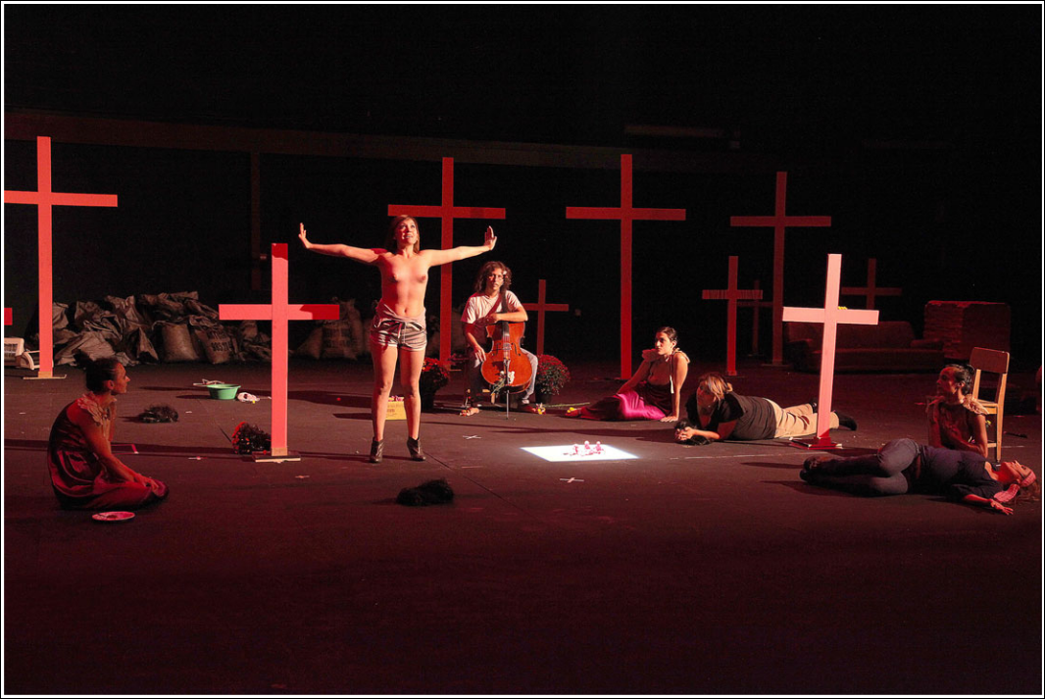

La casa de la fuerza. Photo: courtesy of Julio Calvo.

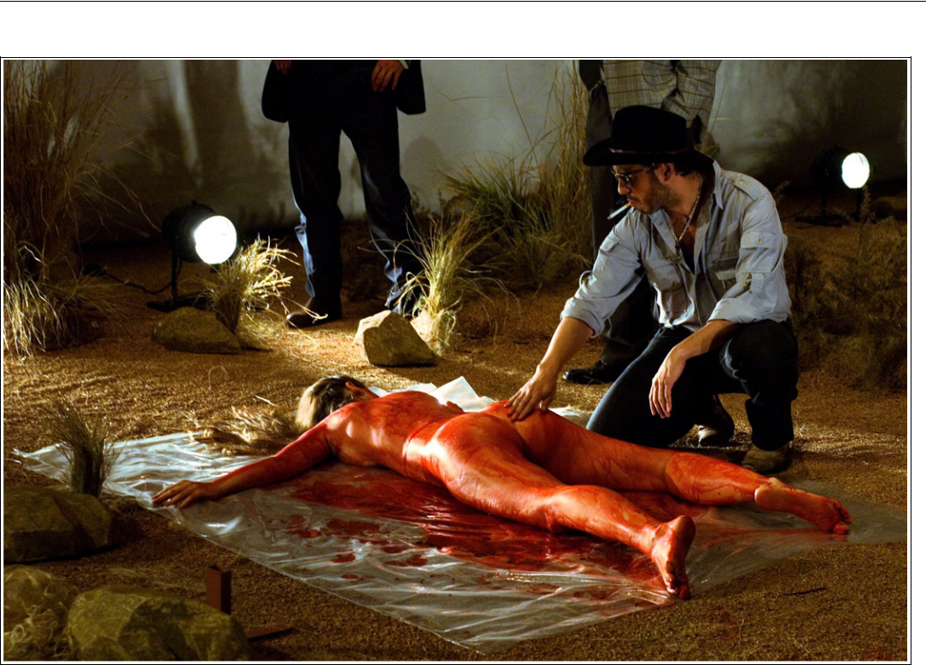

2666. Photo: courtesy of Teatre Lliure.

|  |  |  |
| --- | --- | --- |
| **Downloaded from** [**https://www.cambridge.org/core**](https://www.cambridge.org/core)**. UNSW Library, on 14 Sep 2020 at 03:17:09, subject to the Cambridge Core terms of use, available at** | |  |
| [**https://www.cambridge.org/core/terms**](https://www.cambridge.org/core/terms)**.** [**https://doi.org/10.1017/S0266464X2000024X**](https://doi.org/10.1017/S0266464X2000024X) | 139 |  |
|  |  |

monologue. Admittedly, this passage from The Part About the Crimes is one of the most appalling in the novel. However, choosing to underline it in the play seems to redirect the audience’s empathy for the feminicide victims toward a rather different victim, one that is undeniably secondary to the main plot in the novel.

In short, despite the mournful symbols that invite the audience to feel compassion for the terrible end of the raped and mur-dered women, the message of denouncing machismo is downplayed. While the staging translates the violence of language in the novel by Bolaño, the contextualization and the humanization of the victims are removed, while the voice of possible aggressors – or their local accomplices – is placed in the fore-ground without counterpoints.59 As Driver points out, the inhabitants of Santa Teresa are described in a passage of the novel as ‘more or less dead’, an idea that seems to resound in the shrieking corpse in Rigola’s staging.60 Representing in this manner any form of precarious life can be potentially effec-tive from an aesthetic point of view, but entails several objectionable consequences from an ethical perspective.61 Rigola and Ley’s adap-tation dispossesses its single victim of the attributes that make her human and a citizen, and thus re-inscribes her into the violence that victimizes her, while diluting her particular local history in an image that only dazzles the global spectator, failing to invite a critical comprehension that would render a glocal answer possible.

House of Strength

House of Strength premiered on 16 October 2009 at the Teatro de la Laboral in Gijón (Asturias). In Barcelona, the play was staged in a single showing on 19 February 2011 as part of ‘Radicals Lliure’, a cycle promoted by the Teatre Lliure under the direction of Rigola, which hosted alternative and innovative plays over a period of five years. House of Strength is one of Liddell’s most celebrated plays, gener-ating great expectations in Barcelona, selling out tickets a month before the performance. Written, directed, and also performed by

Liddell, House of Strength is a ‘post-dramatic’62 play that mixes monologues and dialogues, musical interpretations, performative action, and video. Its style is determined by Liddell’s performance, with her strong and aggressive scenic presence, as well as by its eclectic aes-thetics that combine neo-baroque and kitsch elements with multiple literary, filmic, reli-gious, visual-arts, and musical references.

The tension between strength and weak-ness lies at the play’s core, fostering a reflec-tion on strength as a male-gender attribute, constantly and through various approaches. Indeed, male strength exerted against the opposite gender – that is, sexist violence – is the topic that allows a connection between the situations of extreme violence experienced by the women of Ciudad Juárez and the personal experiences of abuse suffered by Spanish women.

The play opens with three Spanish actresses, Angélica Liddell, Getsemaní de San Marco, and Lola Jiménez, who provide examples of this universal phenomenon: they confess to having been victims of violence by different partners. Ironically, they try to over-come their pain in the traditionally male way by complicitly sharing alcohol – beers and mezcal – and tobacco, and singing misog-ynistic rancheras played by an entire mariachi ensemble. Similarly, they recall American films like Fingers, Righteous Kill, and Dirty Harry that exalt the figure of the merciless hero and justify violence – the ‘hypermasculinity’ displayed in Rigola.

During the second act, Liddell relates, with great emotional boldness, the relationship and subsequent break-up she experienced with a male partner who had abused her psycholog-ically. The performer shows intimate proof of her pain, such as photographs and a personal diary written during a trip to Venice, as well as from after the break-up, which includes com-ments on a particularly cruel attack on Gaza, and on regarding another person’s pain. With-out any reserve, she narrates how she worked to overcome this trauma through an intensive programme of gym sessions and casual sexual encounters that she describes as disgusting masochistic strategies to overcome the fears

**Downloaded from** [**https://www.cambridge.org/core**](https://www.cambridge.org/core)**. UNSW Library, on 14 Sep 2020 at 03:17:09, subject to the Cambridge Core terms of use, available at**

[140](https://www.cambridge.org/core/terms)

[**https://www.cambridge.org/core/terms**](https://www.cambridge.org/core/terms)**.** [**https://doi.org/10.1017/S0266464X2000024X**](https://doi.org/10.1017/S0266464X2000024X)

of growing old and of not being loved. After this confession, Lola and Getse recite the cyn-ical letters of a masculine ‘I’ addressed to a female ‘you’, in which several characteristics of ‘extreme masculinity’ are conveyed, such as lack of empathy, the supremacy of one’s own desires, the sexual objectification of women, and the negation of one’s own vulnerability.63 There then follows an extenuating demonstra-tion of physical strength in which the three actresses draw their blood, prior to moving great quantities of coal and several couches around the stage.

The third act opens with a misogynistic corrido sounding across a stage covered with bunches of flowers and the pink crosses of Ciudad Juárez. Three Chihuahuan actresses – María Sánchez, Cynthia Aguirre, and Perla Bonilla – describe the devastating violence that afflicts their country and the phenome-non of the young working women of the maquiladoras who are kidnapped, raped, and killed. Then the three Spanish actresses enter the stage wearing long black wigs and strings around their ankles, mimicking the mur-dered women, and the Mexicans wash their feet and dress them. Then, Catalan cello player and singer Pau de Nut performs three love songs in a cathartic act – songs that are antithetic to the rancheras – while the actresses cover him and his instrument with flowers. Finally, the three Mexicans report a series of feminicides and the existing condemnations against the Mexican government. It is now the Spanish actresses’ turn to take care of their Mexican counterparts, feeding them with tir-amisu, which works in the piece as a symbol of the victims’ strength to get up after the violence they have suffered. As they them-selves explain, ‘tiramisu’ means ‘get me up’ in Italian.64

The final part of the play is an enraged monologue by María Sánchez in which the actress, showing great mental and emotional strength, presents her plan to defeat the strong men that enact violence upon women: she will copulate with her own sons to create a race of weak and useless men. At the end, Juan Carlos Heredia, considered the strongest man in Spain, appears in a sporty costume that reveals his voluminous muscles. After

overturning a car and providing other demon-strations of strength, he lies down on a couch, where the performers cover him with little clay men that symbolize Maria’s sons. This final figure suggests an imagined redemption of the evil perpetrated through the wrong use of male strength in Ciudad Juárez.

Notwithstanding the fact that, while Rigo-la’s piece is limited by servitude to Bolaño’s text, Liddell has full creative freedom, the representation of feminicides in this show and 2666 differs greatly. A first fundamental difference is that, in 2666, the feminicides are placed within a more general reflection on evil and horror whereas in House of Strength they are part of a gender reflection centred on strength as a male attribute. This reflection stems from the personal experience that Lid-dell reveals in the second act: overcoming a traumatic relationship by replacing psycho-logical pain with physical pain in the gym. Liddell’s play is in itself a metaphorical ‘house of strength’ where the performers undertake ‘non-feeling exercises’ in order to overcome pain, such as moving couches and coal, injur-ing themselves, or exhibiting physical force like strongman Juan Carlos.65

However, the play also allows deep reflec-tion on the meanings of strength, both physi-cal and psychological, which is at the origin of atrocities such as those in Gaza, Ciudad Juárez, or the ranchera lyrics. Moreover, as the show unfolds, macho strength is symbol-ically neutralized: Pau de Nut is feminized through flowers, a symbol of femininity; Sán-chez presents her plan to do away with ‘harsh men’;66 and the body of the strongman is colonized by little clay men – Lilliputian ver-sions of ‘weak men’.67 By contrast, other kinds of strength are fostered: the harmless strength of the strongman, which is not deployed against others, or the resilience of those who have been injured and who get up again, such as Liddell herself. This last kind of strength is the one brought to life by the actresses through the therapeutic account of personal traumatic experiences that they share with each other, and undertaking rituals of mutual healing.

Within this frame, the Ciudad Juárez fem-inicides appear as an extreme form of violence

|  |  |  |
| --- | --- | --- |
| **Downloaded from** [**https://www.cambridge.org/core**](https://www.cambridge.org/core)**. UNSW Library, on 14 Sep 2020 at 03:17:09, subject to the Cambridge Core terms of use, available at** | |  |
| [**https://www.cambridge.org/core/terms**](https://www.cambridge.org/core/terms)**.** [**https://doi.org/10.1017/S0266464X2000024X**](https://doi.org/10.1017/S0266464X2000024X) | 141 |  |
|  |  |

that is part of a structure of systemic oppres-sion against women. In this sense, the play allows the topic to transcend the local frame in order to articulate a global narrative. In a manner similar to 2666, ‘explicit criticism of capitalism does not interest Liddell, who pre-fers to dismantle the daily sociability of the patriarchal regime’.68 Also, no stress is placed on the possible identity of the murderers. In this sense, Liddell’s argumentation approaches Rigola’s. She focuses on machismo and the construction of masculinity as a cause of the multiple unpunished feminicides, and starts referring to Mexican machismo through a globally recognizable theme: Mexican folk-loric songs. The rancheras performed by the mariachi troupe fulfil the same function as the jokes told by the group of policemen in 2666 because they justify physical abuse, murder, love as suffering, and female submission to love over all other aspects of life – or, in other words, they justify the myth of romantic love.

Nevertheless, one very significant differ-ence stands between the contextualization of the feminicides in the two plays. While in 2666 machismo is only addressed in the context of Mexican society, in House of Strength the audi-ence hears the report on Mexican violence only through cases of sexist violence in Spain: a rape (Lola), a ‘blow’ received when she told her partner that she wanted to split up with him (Getse), and the psychological abuse suf-fered by Liddell. House of Strength deploys a continuum of acts of sexist violence that mirror each other without an articulated narration, but are linked by cross-cultural references – like lemons and mezcal, and some passages from Chekhov’s play Three Sisters.

While Rigola’s spectator is only shocked by the horror represented, Liddell’s audience is forced to reflect on the similarities between the two countries, and on a violence that hits home, as Spain also has high rates of femini-cide. The contextualization of the Mexican social state of things, more precise than Rigo-la’s, happens in the third act, when the three Mexican actresses present in a referential but sensitive tone the climate of extreme violence that is experienced in Mexico. The dramatic text describes the violence as ubiquitous, and mentions the influence of the drug trade and

the low level of confidence that the police and the government generate.

The second important aspect of this contex-tualization is the detailed description of the accusations that hang over the Mexican gov-ernment due to the Campo del Algodonero case, for which Mexico was judged internation-ally, accused of the ‘violation of women’s right to live free of violence’,69 and of not having committed to ‘eradicating gender stereotypes that dominate and persist in Chihuahua and that have favoured impunity’.70 Therefore, the institutional violence perpetrated by the Mex-ican government is rendered explicit, as well as the fact that feminicides are a possible part of an ‘impunity culture’ and of a society in which ‘the subordinate position of women’ is encour-aged.71 Furthermore, the initial contextualiza-tion ends with a mention of the role of the victims’ mothers as activists through the mur-der of Marisela Escobedo, ‘a mother who had spent three years demanding justice for the murder of her sixteen-year-old daughter Rubí’.72 This detail is important not only because it underlines the high level of impu-nity that surrounds the murders, but also the active reaction of the families, which moves away from the passive victim stereotype.

Other than contextualization, the main dif-ference between 2666 and House of Strength is their representation of the victims. In House of Strength, no list is provided and there is not a main single case, either. The three Mexican actresses report a heterogeneous sample of cases: the murder of Paulina Elizabeth Luján Morales, the eight bodies found in the Campo del Algodonero, and the eleven murdered women on a list collected and read out by Cynthia during Independence Day in Mexico. The fact that the majority of the victims are maquiladora workers is underlined (although, similarly to 2666, their often-indigenous ori-gin is neglected) and Cynthia’s explanation highlights how the victims are also victimized as workers in the capitalist system. In this way, as in Bolaño’s novel, the inter-section between gender and class is under-lined. Cynthia reveals that these young women, often between ‘fourteen and fifteen years old’, belong to ‘very poor families and need to work, so they go and ask for work in

**Downloaded from** [**https://www.cambridge.org/core**](https://www.cambridge.org/core)**. UNSW Library, on 14 Sep 2020 at 03:17:09, subject to the Cambridge Core terms of use, available at**

[142](https://www.cambridge.org/core/terms)

[**https://www.cambridge.org/core/terms**](https://www.cambridge.org/core/terms)**.** [**https://doi.org/10.1017/S0266464X2000024X**](https://doi.org/10.1017/S0266464X2000024X)

the factories’, where they spend ‘ten or twelve hours assembling in the line’.73 And because they live outside the city, ‘they need to cross empty lots, where we know that it is there

where they kidnap them and they take them, but they have to go to work’.74

The description of the multiple cases does not avoid details of the dreadful deaths of the victims. However, these descriptions are framed by gender considerations of the phenomenon – that women are killed because of their gender as objects of male desire and hatred; that they are killed far more brutally than men, and that their memory is violated by the media and the institutions. These descriptions are also accompanied by elements that seek to create an empathetic reaction towards the victim and that favour a wider vision that goes beyond ‘the sum of the violence written on her body’.75 For instance, the passage on the murder of Luján Morales closes with her desires and opinions before she is brutally raped and murdered:

Paulina Elizabeth Luján Morales was sixteen years old, / she wanted to learn languages and be a flight attendant to travel the world, / before being raped and killed on 12 March 2008, / she wrote in her MetroFLOG, / among pink flowers and butterflies,

* that she didn’t like lies and that she was from Chihuahua, / and that she was sixteen years old.76

Together with all the divergences listed, perhaps the most remarkable difference between 2666 and House of Strength is that, in the latter, sexist violence is reported by its main witnesses: its victims – direct in the case of the Spanish actresses and indirect in the case of the Mexican ones. Both Mexican and Spanish women’s voices are placed at the centre, and the actresses appear as creators of the narrative that defines them and con-veys their plight to the public. They thus transgress the centuries-old assumption that oratory is a male patrimony.77 With the three Chihuahuan actresses, Liddell follows the current trend in European theatre of explain-ing a conflict through the presence of its witnesses onstage. In House of Strength, the Mexican actresses appear as holders of the victims’ memory, voices close to the

impossible testimony of the murdered women who would be the perfect witnesses, but are already inaccessible.78

Moreover, the Mexican actresses are infused with authority, as they speak about a conflict little known to the Spanish audience. They also develop their exposition critically, reporting responsibilities and effectively expressing their own point of view and how they feel. Their physical language fore-grounds their agency. They stand upright at the centre of the stage, looking at the audience face to face while they deliver their informed but also vehement speech. In this sense, their bodies radically oppose the recumbent, mute, blind, and powerless body that Rigola pre-sents to his public. In House of Strength, the female bodies contrast with the male ones, who barely talk and concentrate on other tasks

– music and physical strength.

Rigola’s and Liddell’s pieces are also radi-cally different in their treatment of nakedness. In 2666, the only victim that the public gets to see is dehumanized and sexualized in a way that marks her body with the stigmas of avail-ability and Otherness. Authors such as Schnei-der and, more recently, Sarah Gorman have defended the possibility for the female body to escape the patriarchal discourses that reduce women to immanence – linking them to the terrain of the corporeal, while the masculine is related to transcendence – and showing ‘the possibility of “control” and . . . the possibility of full subject-hood while proudly occupying

1. female body’.79 In House of Strength, the presentation of the naked female body dispels the image of the passive victim, so obliging to a symbolic system that erotizes violence, in order to present the image of women with agency who, therefore, fight back.

To begin with, the six actresses form an uncommon casting: seeing six women in con-trol of their own discourses is still rare on Spanish stages today. Their appearance as non-normative bodies makes them still more exceptional. The Spanish actresses’ bodies are older than forty, one Mexican actress is over-weight and another is pregnant. These six non-normative female bodies incarnate authority and vindication of their own sub-jectivities and bodies ‘[b]y insisting upon their

|  |  |  |
| --- | --- | --- |
| **Downloaded from** [**https://www.cambridge.org/core**](https://www.cambridge.org/core)**. UNSW Library, on 14 Sep 2020 at 03:17:09, subject to the Cambridge Core terms of use, available at** | |  |
| [**https://www.cambridge.org/core/terms**](https://www.cambridge.org/core/terms)**.** [**https://doi.org/10.1017/S0266464X2000024X**](https://doi.org/10.1017/S0266464X2000024X) | 143 |  |
|  |  |

right to occupy a traditionally male role, and by articulating the experience of sexual differ-ence while in role, they are resisting, assimi-lation to an androcentric model.80 In this sense, if the three Spanish actresses show their naked breasts during the first act, they do it while lifting weights – after having talked about episodes of sexist violence experienced on their own bodies. There is no doubt about who is the victim – differently to the stress puton the story of Klaus Haas in 2666 – or about the victims’ lucid perception of their own situation.

While Liddell, like Bolaño, does not foster ‘any stated goals related to fomenting social change in Juárez’,81 she offers a narrative and an ensemble of theatre images of recognition and reparation that are effective on a symbolic level. The scenes of healing and consolation in the third act work as a ritual identification of the actresses with the murdered women: the Spanish actresses mimic the victims in the ‘wigs scene’ and during the Mexicans’ expla-nation of the feminicides, when they lie inert on the floor with their underwear pulled

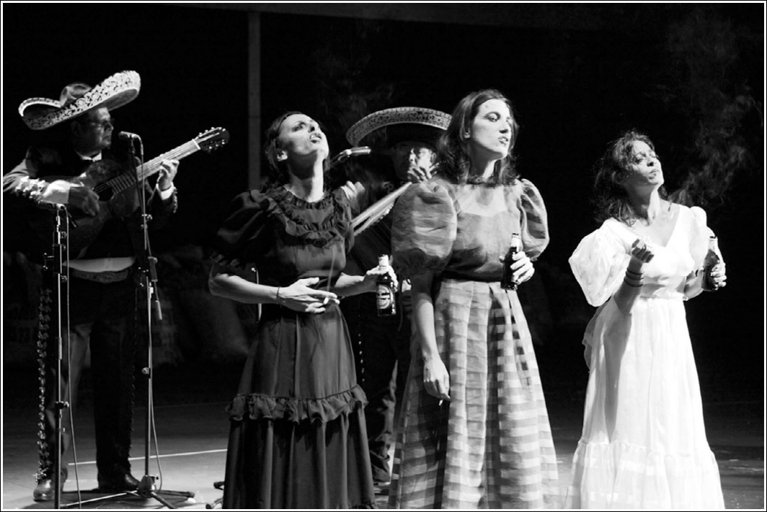

down to their knees – while still wearing their dresses. For their part, the Mexicans repro-duce postures of vulnerability when they lie on the floor to be fed with tiramisu. In doing so, the six actresses identify alternately with the victims and with the women who take care of them in a representation of empathy, ten-derness, and soothing physical contact oppo-site to the physical language of Rigola’s policemen.

Furthermore, the religious references – descent from the cross in the first act and the vertical legs against the pink crosses in the third act – suggest a subversive reading of the martyrdom of Christ, translated here into a female version. This ensemble of ritual actions of empathy fosters an empathetic reaction from the audience that avoids stres-sing the Otherness of the victims and under-lines their capacity to react, which is neatly different from Rigola’s 2666. In the third act, care is vindicated instead of violence and aggression, and the acknowledgement of the Others and the attention to their pain is underscored as a way of reparation towards

La casa de la fuerza. Photo: courtesy of Julio Calvo.

**Downloaded from** [**https://www.cambridge.org/core**](https://www.cambridge.org/core)**. UNSW Library, on 14 Sep 2020 at 03:17:09, subject to the Cambridge Core terms of use, available at**

[144](https://www.cambridge.org/core/terms)

[**https://www.cambridge.org/core/terms**](https://www.cambridge.org/core/terms)**.** [**https://doi.org/10.1017/S0266464X2000024X**](https://doi.org/10.1017/S0266464X2000024X)

the victims. Nevertheless, the victims’ reac-tion is far from being lenient, as it culminates in Maria Sánchez’s monologue, a transgres-sive passage not only because it presents a plan relying on incest, but also because it stands close to the caricatured version of an enraged and threatening feminism that, in a Western world claiming to have reached gen-der equality, is dismissed as a vindication that belongs to the past.82

The third act of House of Strength, while not entirely political – Maria’s programme obvi-ously cannot be translated outside the stage – constitutes ‘an ethical decision that opens a political action’,83 because, through a new narrative in the representation of victims, it offers a different message to the public: ‘It is this freedom [of women] that this play exer-cises, on the stage, thanks to the unity between biographies, characters, and performance, allowing the women of the stage and the audi-ence to acquire the strength to respond.’84 House of Strength is a show conscious of the fact that artworks are ‘forms of imaginative reconstruction’ of both the memory and the identity of the victims, and it clearly makes an effort not to reproduce the symbols and the images that would victimize them again.85 In doing so, it allows the audiences to imagine a world where women have a voice, where the female body generates discourse, where those responsible for the crimes are pointed to, where the public is confronted with its respon-sibility, where alternative narratives to vio-lence are proposed, where the consequences of gender are discussed, where the Other is recognized, and, finally, where feminist soli-darity, that is, sorority, prevails. From our point of view, Liddell achieves what Driver demands for new representations of the Ciu-dad Juárez feminicides: ‘Future cultural pro-duction must continue to move beyond trauma discourse, beyond crying mothers, beyond sexualized bodies in order to address the matrix of gender inequalities that continue to contribute to feminicide.’86

Conclusion

Our comparative analysis has shown that the representation of the Ciudad Juárez

feminicide victims in 2666 and House of Strength is radically different in terms of gen-der. Rigola brings to the stage a single proto-typical victim who falls into several stereotypes of patriarchal narratives and chooses the risky strategy of denouncing machismo through its most extreme codes. The production’s features – music, pink crosses, and the list of murdered women – are of a symbolic nature and remain in the background, less prominent than the victim’s body and the policemen. Therefore, these ele-ments are unable to stand as a sufficient coun-terpoint to the deployment of the extreme masculinity that frames the corpse, which is an extreme incarnation of vulnerability.

In Butler’s opinion, even though no vio-lence is shown, the victim’s subject-hood seems to be de-realized by the same codes that mark her body as interchangeable, rapeable and ultimately killable in real life, thus re-inscribing it in the web of violence that prevents her from being anything but a victim. Although Bolaño’s novel explores ‘the meta-physics of horror and evil without articulating any stated goals related to fomenting social change in Juárez’, it clearly fosters a discourse of denunciation, especially in The Part About the Crimes.87 In the staging, unfortunately, the drastic reduction of much of the contextual information about the crimes makes it virtu-ally impossible to elaborate a discourse of denunciation beyond the long and swift memorial of the dead. One of the most symp-tomatic consequences of this aesthetic option is that critics have univocally interpreted Rigola and Ley’s adaptation as a tribute to the great Chilean writer who died in Barce-lona and not as a homage to the Mexican victims.

This scenic proposal contrasts strongly with Liddell’s play, which, with six actresses, gives entire prominence to the voice of women and their subjectivities and thus avoids their de-realization or de-humanization. Although Liddell does not postulate a political pro-gramme for the emancipation of women, her poetic proposal coincides with what would be a feminist treatment of the victims: giving them a voice, putting sorority and care into the fore-ground, and proposing gender reflection. The

|  |  |  |
| --- | --- | --- |
| **Downloaded from** [**https://www.cambridge.org/core**](https://www.cambridge.org/core)**. UNSW Library, on 14 Sep 2020 at 03:17:09, subject to the Cambridge Core terms of use, available at** | |  |
| [**https://www.cambridge.org/core/terms**](https://www.cambridge.org/core/terms)**.** [**https://doi.org/10.1017/S0266464X2000024X**](https://doi.org/10.1017/S0266464X2000024X) | 145 |  |
|  |  |

more complete and reliable information that Liddell’s audience obtains provides a much more favourable framework to an understand-ing of the complexity of the Ciudad Juárez feminicides. In addition, the sexual abuses and tortures suffered by the victims are reported while avoiding degrading and sexist imagery. In this sense, Liddell’s victims incar-nate the possibility of theatrical representations in which women’s lives are visible and diverse, and therefore no longer ‘unrepresentable’.88

The corporal representation of the victims is the element that most clearly sums up all these differences. In general terms, the male-authored play reproduces the discourse/body split, in which the masculine owns the dis-course sphere and the feminine is relegated to the corporeal sphere, consequently alienating the female body from the discourse. On the contrary, in the female-authored play, the female bodies produce discourse, thus sub-verting the traditional narrative of the feminine body as immanent.89 In this way, while Rigola reifies the traditional alienation of female bod-ies from discourse altogether with the sexuali-zation of violence, Liddell’s play responds to the promotion of recognition and respect toward alterity that Assmann claims, as a basis for a symbolic proposal of reparation and heal-ing.90 These very differently represented vic-tims are also framed by different troupes. In Rigola, a homogeneous and mostly male cast-ing serves as a frame for the exposure of a body re-inscribed in violent discourses; in House of Strength, by contrast, the centrality and agency of the female bodies, as well as their diversity, stand as a claim for women’s rights to be represented without violence.

Ultimately, we wish to point out that plays like 2666 and House of Strength are devices for the memorialization of women who have been victims of several intermingled oppres-sions, comprising global capitalist violence and local machismo. Every artwork aiming to speak for them needs to be highly aware that gender, class, or race discourses entrenched in artistic representation can be damaging to their memories, perhaps even more so when produced and represented in hegemonic cultural centres from the global North such as Barcelona, which are far away

from the conflict; cultural and geographical dis-tances may make things dimmer. In this sense, these kinds of representations of the Ciudad Juárez feminicides should entail reflection on how they often cross with alien purposes – such as the enlargement of Bolaño’s global fame, the exorcizing of personal experiences, or the will-ingness to take a didactic approach toward sexist violence – and whether or not they involve an ethical risk that is too high.

Notes and References

1. Kia Lindroos and Frank Möller, eds., Art as a Polit-ical Witness (Opladen, Berlin, Toronto: Barbara Budrich Publishers, 2017), p. 51.

2. Slavoj Žižek, Against the Double Blackmail: Refugees, Terror and Other Troubles with the Neighbours (London: Allen Lane, 2016).

3. Alexander Beecroft, ‘On the Tropes of Literary Ecol-ogy: The Plot of Globalization’, in Jerjej Habjan and Fabi-enne Iminger, eds., Globalizing Literary Genres (London; New York: Routledge, 2016), p. 195–212.

4. Dunia Gras Miravet, ‘Del texto al escenario: La dramaturgia de 2666 (Bolaño-Rigola-Gosselin)’, Orillas, VI (2017), p. 107–33.

5. Elisa García Mingo, ‘Cuando los cuerpos hablan. La corporalidad en las representaciones sobre la violencia sexual en las guerras de la República del Congo’, Revista de Dialectología y Tradiciones Populares, LXX, No.1 (2015), p. 176.

6. Elena Grau, ‘Vivir en un cuerpo violable’, En pie de paz, XXVIII (1993), p. 47.

7. Jessica Auchter, ’The Politics of Looking at the Corpse’, Global Discourse, VII, Nos. 2–3 (2017), p. 223–38.

8. Judith Butler, Precarious Life: The Powers of Mourn-

ing and Violence (London, New York: Verso, 2004), p. 147.

9. Ibid., p. 148.

10. Ibid.

11. 2666 premiered in Barcelona during the Grec Fes-tival (27–30 June 2007) and ran at Teatre Lliure during two non-consecutive seasons: 2007–2008 (8–25 November 2007) and 2009–2010 (5–7 February 2010; <[https://www.](https://www.youtube.com/watch?v=Ze4i-tPDn-U) [youtube.com/watch?v=Ze4i-tPDn-U](https://www.youtube.com/watch?v=Ze4i-tPDn-U)>). Rigola also directed a German-language version of the play at the Schaubühne theatre in Berlin and presented the Spanish-language version in Madrid, Santiago de Chile, and Bogotá, among others. House of Strength was staged at Teatre Lliure on one single occasion (19 February 2011; <<https://www.youtube.com/watch?v=qy1QmZRQKwg>>). Liddell also brought her piece to Madrid, as well as other Spanish cities, and to the Avignon Festival in France. Àlex Rigola is a theatre director mainly dedicated to contem-porary textual theatre and Shakespearean plays and con-sidered an enfant terrible of European theatre because of his risky mises en scène.

12. This title, La casa de la fuerza (translated as House of Strength in English), bears comparison with La casa de Bernarda Alba (The House of Bernarda Alba) by Federico García Lorca, which is also a female-centred play that tells the story of female oppression in a traditionally patriarchal society. Angélica Liddell (pseudonym of Angélica

**Downloaded from** [**https://www.cambridge.org/core**](https://www.cambridge.org/core)**. UNSW Library, on 14 Sep 2020 at 03:17:09, subject to the Cambridge Core terms of use, available at**

[146](https://www.cambridge.org/core/terms)

[**https://www.cambridge.org/core/terms**](https://www.cambridge.org/core/terms)**.** [**https://doi.org/10.1017/S0266464X2000024X**](https://doi.org/10.1017/S0266464X2000024X)

González) is a playwright, director, and performer, con-sidered by many as a benchmark figure in European avant-garde theatre. With House of Strength, she embarked on a new creative journey centred on post-dramatic pieces that have subsequently earned her success throughout Europe.

13. See Mary Beard, ’The Public Voice of Women’, The London Review of Books, XXXVI, No. 6 (20 March 2014),

1. 11–14.

14. Maquiladoras, or maquilas, are mainly foreign cap-ital factories, which pay very low salaries and provide little job security.

15. Slavoj Žižek, Violence: Six Sideways Reflections

(London: Profile Books, 2008), p. 11.

16. Laura Gillman and Tobias Jochum, ‘New Interdis-ciplinary Perspectives on Feminicide at the U.S.-Mexico Border’, FIAR, VIII, No. 2 (2015), p. 4–19.

17. Miguel López-Lozano, ‘Women in the Global Machine: Patrick Bard’s La frontera, Carmen Galán Benitez’s Tierra marchita, and Alicia Gaspar de Alba’s Desert Blood: The Juárez Murders’, in Héctor Domínguez-Ruvalcaba and Ignacio Corona, eds., Gender Violence at the U.S.-Mexico Border: Media Representation and Public Response (Tucson: University of Arizona Press, 2010), p. 128.

18. Rosa-Linda Fregoso and Cynthia Bejarano, ‘Intro-duction: A Cartography of Feminicide in the Américas’, in Rosa-Linda Fregoso and Cynthia Bejarano, eds., Terroriz-ing Women: Feminicide in the Américas (Duke: Duke Uni-versity Press, 2010), p. 5.

19. Roberto Ponce-Cordero, ‘A Dynamo of Violent Stories: Reading the Feminicidios of Ciudad Juárez as Narratives’ (unpublished PhD thesis, University of Pitts-burgh, 2016), p. iv.

20. Adriana Carmona López, Alma Gómez Caballero, and Lucha Castro Rodríguez, ‘Feminicide in Latin Amer-ica in the Movement for Women’s Human Rights’ in Fregoso and Bejarano, eds., Terrorizing Women, p. 158.

21. Fregoso and Bejarano, ‘Introduction: A Cartography of Feminicide in the Américas’, Terrorizing Women, p. 7.

22. Alice Driver, More or Less Dead: Feminicide, Haunt-ing, and the Ethics of Representation in Mexico (Tucson: The University of Arizona Press, 2015), p. 73.

23. Ibid.

24. Ana Prieto Nadal, ‘La narrativa de Roberto Bolaño a escena: 2666’, Revista de literatura, LXXVIII, No. 156

(2016), p. 543–67.

25. Roberto Bolaño, 2666 (Barcelona: Anagrama,

2004).

26. Marcos Ordóñez, ‘Cinco horas con Bolaño’, Babe-lia. El País, 14 July 2007, p. 20.

27. Sergi Doria, ‘El secreto del mundo’, ABC, 29 June 2007, p. 69; Juan Carlos Olivares, ‘Els fantasmes de Santa Teresa’, Avui, 29 June 2007, p. 50.

28. Daniel Hernández Guzmán, ‘Más allá de los fem-inicidios: violencia y cuerpo femenino en “La parte de los crímenes” de Roberto Bolaño’, Cuadernos de literatura, XX, No. 40 (2016), p. 639.

29. Ibid.

30. Ana Del Sarto, ‘Los afectos en los estudios cultur-ales latinoamericanos: cuerpos y subjetividades en Ciudad Juárez’, Cuadernos de Literatura, No. 34 (2012), p. 62.

31. Hernández Guzmán, ‘Más allá de los feminici-dios’, p. 641.

32. Driver, More or Less Dead, p. 175.

33. Ibid.

34. Hernández Guzmán, ‘Más allá de los feminici-dios’, p. 641.

35. Nadal, ‘La narrativa de Roberto Bolaño a escena’, p. 557.

36. Ibid., p. 563, 565.

37. Nadal, ‘La narrativa de Roberto Bolaño a escena’; Gras Miravet, ‘Del texto al escenario’.

38. Gabriela Cordone, ‘2666 en escena: relato, imagen y mestizaje artístico’, Revista Letral, No. 11 (2013), p. 18.

39. In the novel, the scene containing sexist jokes takes place in a bar.

40. José Ramón López García, ‘El mal en escena: 2666, de Roberto Bolaño’, in José Romera Castillo, ed., Teatro, novela y cine en los inicios del siglo XXI (Madrid: Visor Libros, 2008), p. 15.

41. Ordóñez, ‘Cinco horas con Bolaño’.

42. Jean Franco, Plotting Women: Gender and Represen-

tation in Mexico (New York: Columbia University Press,

1989), p. 15.

43. Fregoso and Bejarano, ‘Introduction: A Cartogra-phy of Feminicide in the Américas’, p. 51.

44. Rita Laura Segato, La guerra contra las mujeres (Madrid: Traficantes de Sueños, 2016), p. 113.

45. Daniel Cazés Menache, ‘La misoginia: ideología de las relaciones humanas. Una introducción’, in Daniel Cazés Menache and Fernando Huertas Rojas, eds., Hom-bres ante la misoginia (México D.F.: Centro de Investiga-ciones Interdisciplinarias en Ciencias y Humanidades, UNAM, Plaza y Valdés, 2005), p. 12.

46. Jill Dolan, The Feminist Spectator as Critic (Michi-gan: The University of Michigan Press, 2012), p. 1.

47. Laura Mulvey, ‘Visual Pleasure and Narrative Cinema’, Screen, XVI, No. 3 (1975), p. 11.

48. See Beard, ‘The Public Voice of Women’.

49. Gayatri Chakravorty Spivak, ‘Can the Subaltern Speak?’, in Cary Nelson and Lawrence Grossberg, eds., Marxism and Interpretation of Culture (Urbana, Chicago: University of Illinois Press, 1988), p. 271–313.

50. Rebecca Schneider, The Explicit Body in Perfor-mance (London; New York: Routledge, 1997), p. 51.

51. Ibid.

52. Miriam Haughton, Staging Trauma: Bodies in

Shadow (London: Palgrave Macmillan, 2018), p. 5, 14.

53. Katha Pollitt, ‘The Smurfette Principle’, The New York Times Magazine, No. 140, April 7 (1991), p. 22.

54. Auchter, ‘The Politics of Looking at the Corpse’,

1. 224.

55. Susan Sontag, Regarding the Pain of Others (New York: Picador, 2003), p. 70.

56. Pablo Ley and Àlex Rigola, 2666. Roberto Bolaño (Barcelona: Fundació Teatre Lliure, 2007), n.p.

57. Roberto Bolaño, 2666, trans. Natasha Wimmer (London: Picador, 2009), p. 466.

58. Ley and Rigola, 2666, n.p.

59. Ángeles Donoso Macaya, ‘Estética, política y el posible territorio de la ficción en 2666 de Roberto Bolaño’, Revista Hispánica Moderna, LXII, No. 2 (2009), p. 125–42.

60. Bolaño, 2666, trans. Wimmer, p. 624.

61. See Butler, Precarious Life.

62. See Hans-Thies Lehmann, Postdramatic Theatre (London: Routledge, 2006).

63. Franco, Plotting Women, p. 15.

64. Angélica Liddell, La Casa de la fuerza. Te haré inven-cible con mi derrota. Anfaegtelse (Segovia: La Uña Rota,

2011), p. 55.

65. Ibid., p. 68.

66. Ibid., p. 118.

67. Ibid., p. 119.

|  |  |  |
| --- | --- | --- |
| **Downloaded from** [**https://www.cambridge.org/core**](https://www.cambridge.org/core)**. UNSW Library, on 14 Sep 2020 at 03:17:09, subject to the Cambridge Core terms of use, available at** | |  |
| [**https://www.cambridge.org/core/terms**](https://www.cambridge.org/core/terms)**.** [**https://doi.org/10.1017/S0266464X2000024X**](https://doi.org/10.1017/S0266464X2000024X) | 147 |  |
|  |  |

68. Jorge Louraço Figueira, ‘La Casa de la Fuerza por Angélica Liddell’, E-misférica 8.2 #narcomachine (2011), <<http://hemisphericinstitute.org/hemi/fr/e-misferica-82/figueira>> (accessed 5 January 2019).

69. Liddell, La Casa de la fuerza, p. 113.

70. Ibid., p. 114.

71. Ibid.

72. Ibid., p. 115.

73. Ibid., p. 102.

74. Ibid.

75. Driver, More or Less Dead, p. 73.

76. Liddell, La Casa de la fuerza, p. 112.

77. Beard, ‘The Public Voice of Women’.

78. Oscar Cornago Bernal, ‘Alegorías de la actuación. El actor como testigo’, Acotaciones: revista de investigación teatral, No. 28, p. 55–74.

79. Sarah Gorman, ‘Feminist Disavowal or Return to Immanence?: The Problem of Poststructuralism and the Naked Female Form in Nic Green’s Trilogy and Ursula Martinez’s My Stories, Your Emails’, Feminist Review, No. 105 (2013), p. 57.

80. Ibid., p. 60.

81. Driver, More or Less Dead, p. 170.

82. Clare Hemmings, Why Stories Matter: The Political Grammar of Feminist Theory (Durham, N.C.: Duke Univer-sity Press, 2010), p. 9–10.

83. José Antonio Sánchez, ‘Discurso escénico y cor-poralidad’, in Carles Batlle, Enric Gallén, and Mònica Güell, eds., Drama contemporani: renaixença o extinció? (Lleida; Barcelona; Paris: Punctum; Institut del Teatre, Universitat Pompeu Fabra; Université Paris-Sorbonne, 2016), p. 137.

84. Figueira, ‘La Casa de la Fuerza por Angélica Lid-dell’.

85. Astrid Erll, ‘Traumatic Pasts, Literary Afterlives, and Transcultural Memory: New Directions of Literary and Media Memory Studies’, Journal of Aesthetics and Culture, III, No. 1 (2011), p. 2.

86. Driver, More or Less Dead, p. 44.

87. Ibid., p. 170.

88. Butler, Precarious Life, p. 147.

89. Gorman, ‘Feminist Disavowal or Return to Imma-nence?’.

90. Aleida Assmann, ‘Civilizing Societies: Recogni-tion and Respect in the Global World’, New Literary His-tory, XLIV, No. 1 (2013), p. 69–91.

The authors have translated all the non-English original citations except for passages from 2666, which have been taken from Natasha Wimmer’s translation.

**Downloaded from** [**https://www.cambridge.org/core**](https://www.cambridge.org/core)**. UNSW Library, on 14 Sep 2020 at 03:17:09, subject to the Cambridge Core terms of use, available at**

[148](https://www.cambridge.org/core/terms)

[**https://www.cambridge.org/core/terms**](https://www.cambridge.org/core/terms)**.** [**https://doi.org/10.1017/S0266464X2000024X**](https://doi.org/10.1017/S0266464X2000024X)